Keyword Analysis

## **Key metrics**:

1. [**Volume**](https://www.semrush.com/kb/683-what-is-search-volume-in-semrush)**:** the average number of times per month that a keyword was queried on Google (on the national/local level).
2. [**Keyword Difficulty (KD)**](https://www.semrush.com/kb/1434-how-is-personalized-keyword-difficulty-calculated)**:** is calculated using AI algorithms to analyze any domain's relevance to any specific keyword.
3. [**Intent**](https://www.semrush.com/blog/analyze-search-intent-instantly/)**:** the purpose of a user’s query in a search engine. The main types of search intents are: informational, navigational, commercial, and transactional.

**Informational intent** will bring users who want to learn about a topic.It won’t lead to immediate conversions but can increase brand awareness and generate leads over time.

**Commercial intent** will bring users seeking information to make a decision before taking action (e.g., a purchase).It has high chances of converting visitors into customers.

**Preference: Informational < Navigational < Commercial < Transactional**

## **Goal:**

Find out the keywords with **high volume, low keyword difficulty, and preferably commercial intent**

Reference: <https://www.semrush.com/kb/257-keyword-overview#kdscore>

## **Recommendation:**

Strategy one:

Choose the keywords that are within the seed keywords that has the largest average search volume:

## 

Strategy two:

Choose the keywords that has the highest volume but lower keyword difficulty

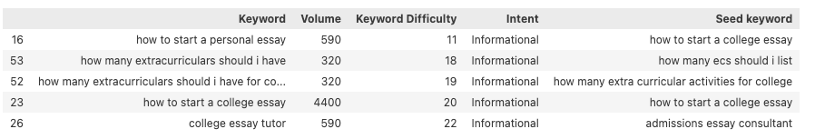

## **More to focus:**

1. Pay Attention to the **Local keyword metrics.**

It’s possible to get keyword metrics not only on a national but also on a local level. If we are targeting a specific area in the future, we could add this filter to evaluate the organic traffic potential of a keyword in your specific location.

1. Check the **trend**:

The trend chart in the Semrush report shows whether a keyword’s search volume fluctuates throughout the year or stays relatively constant. If a keyword has a seasonal spike, we may think about changing the keywords in our ads seasonally.